### 

# #3: AC Measurements

Christopher Badolato

Yajaira Varillas Perez

EEL3123C-0013

2/13/2019

## Objectives

* To understand the basics of AC (alternating current) circuits.
* To use an oscilloscope to display and record a waveform.
* To use an oscilloscope to measure frequency, period, voltage (magnitude, peak-to-peak, maximum, minimum, and etc), DC offset, etc, of the waveform.
* To use a digital multimeter to measure AC voltage and current.

## Equipment

* Function generator
* Oscilloscope
* Digital multimeter (DMM)

## **Simulation**

In MultiSim, construct a circuit consisting of a function generator, a DMM, a ground and an oscilloscope.

1. Set the function generator to output a 1kHz, 10 Vpp sine wave.
2. Display the output on Ch.A of the oscilloscope by connecting the positive terminal of the function generator to the positive terminal of the oscilloscope and the common terminal **(not the negative terminal)** of the function generator to the negative terminal of the oscilloscope.
3. On the oscilloscope display, adjust the time scale and/or amplitude scale if needed. You can click ‘Single’ to instruct the oscilloscope to produce a stable waveform. Measure the frequency (period) and Vpp using cursors. Verify that the frequency and amplitude of the displayed sine wave match the values set in the function generator.
4. With the DMM set to measure AC voltage, measure the output of the function generator by connecting the positive terminal of the function generator to the positive terminal of the DMM and the common terminal **(not the negative terminal)** of the function generator to the negative terminal of the DMM. Which measurement is this DMM reading equal to, Amplitude or RMS?

|  |
| --- |
| The measurement the DMM reading is equal to the RMS voltage from the function generator. |

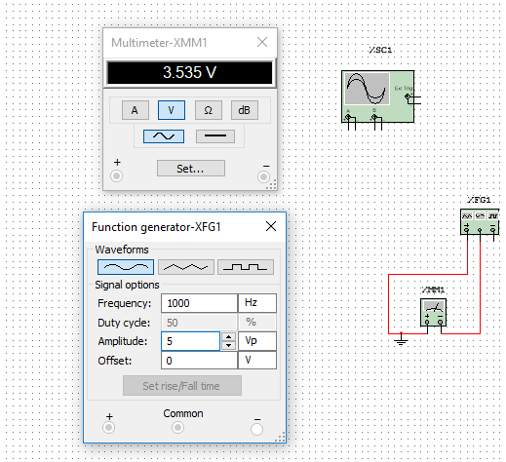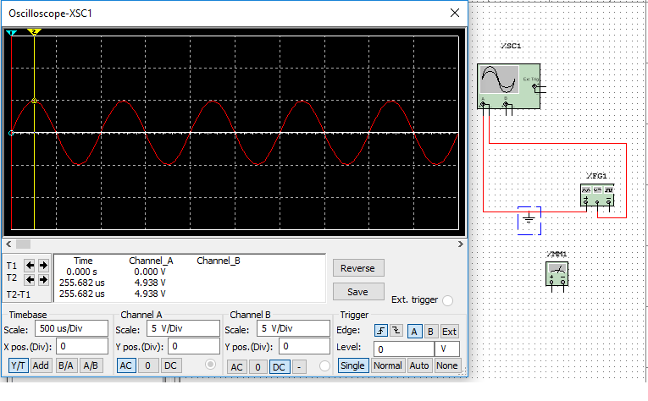

|  |
| --- |
| As we can see for each wave case, the measured value is equal to the RMS voltage. |

Square Wave:

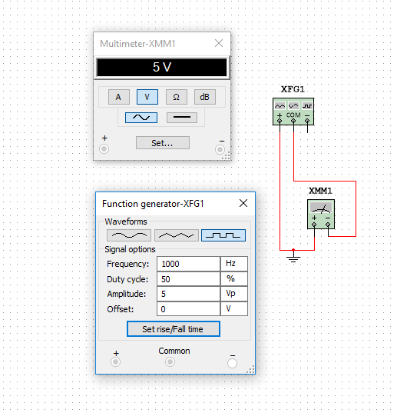

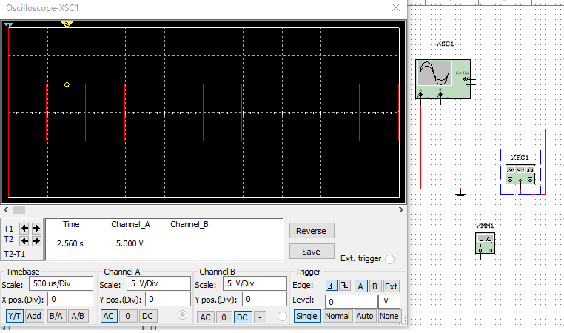

Triangle Waves:

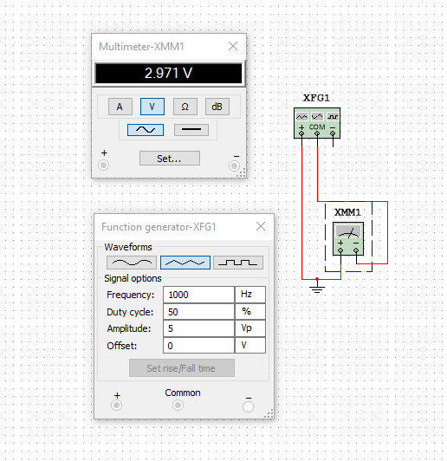

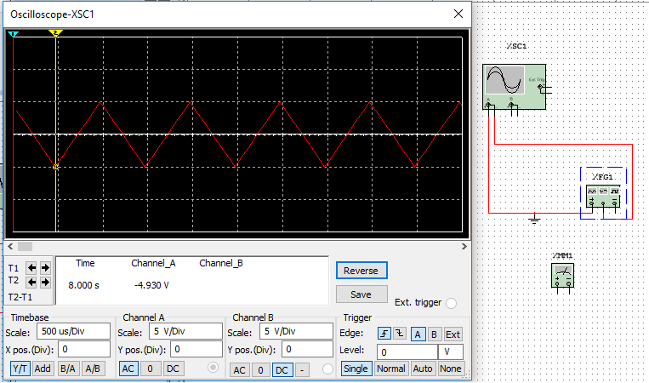

1. Set the function generator to output a 1kHz, 10 Vpp sine wave again.
2. With the negative terminal **(not the common terminal)** of the function generator now connected to both the negative terminals of the oscilloscope and the DMM, observe the reading on the DMM as well as measure the frequency (period) and Vpp using cursors on the oscilloscope. Comparing to steps 2 and 4, which measured values have changed? Provide a detailed explanation to justify the changes.

|  |
| --- |
| We can see below, from each wave type that our values have double for our voltages, that is because the oscilloscope and the dmm are in parallel and each has its own internal resistance. |

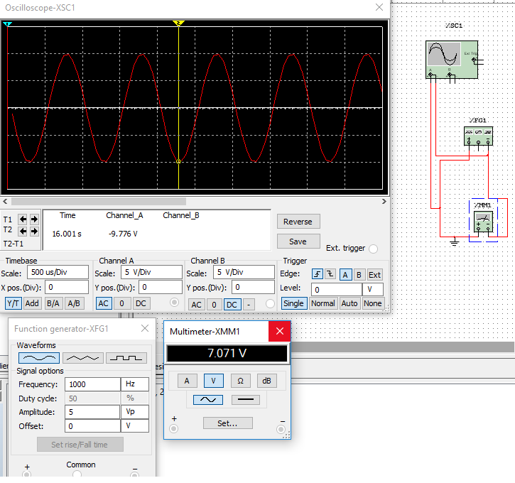

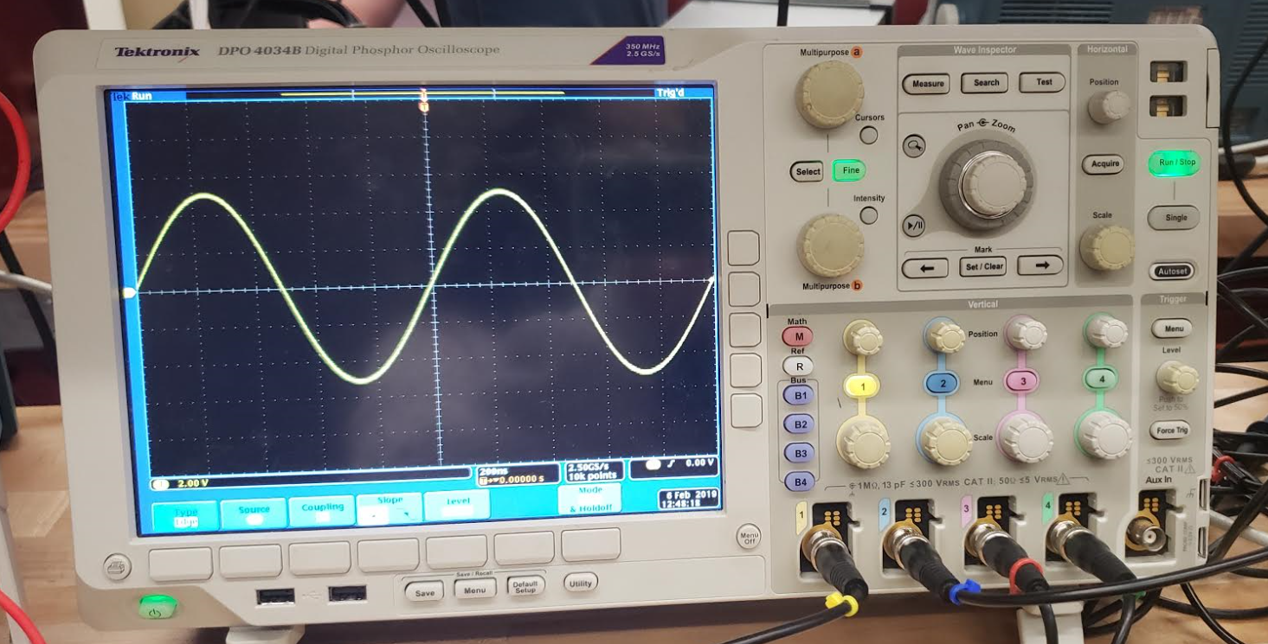

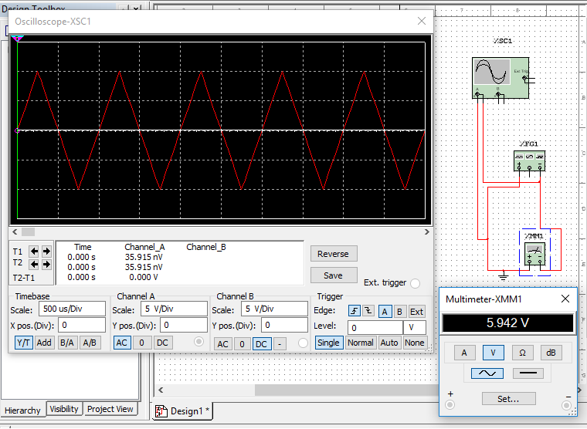

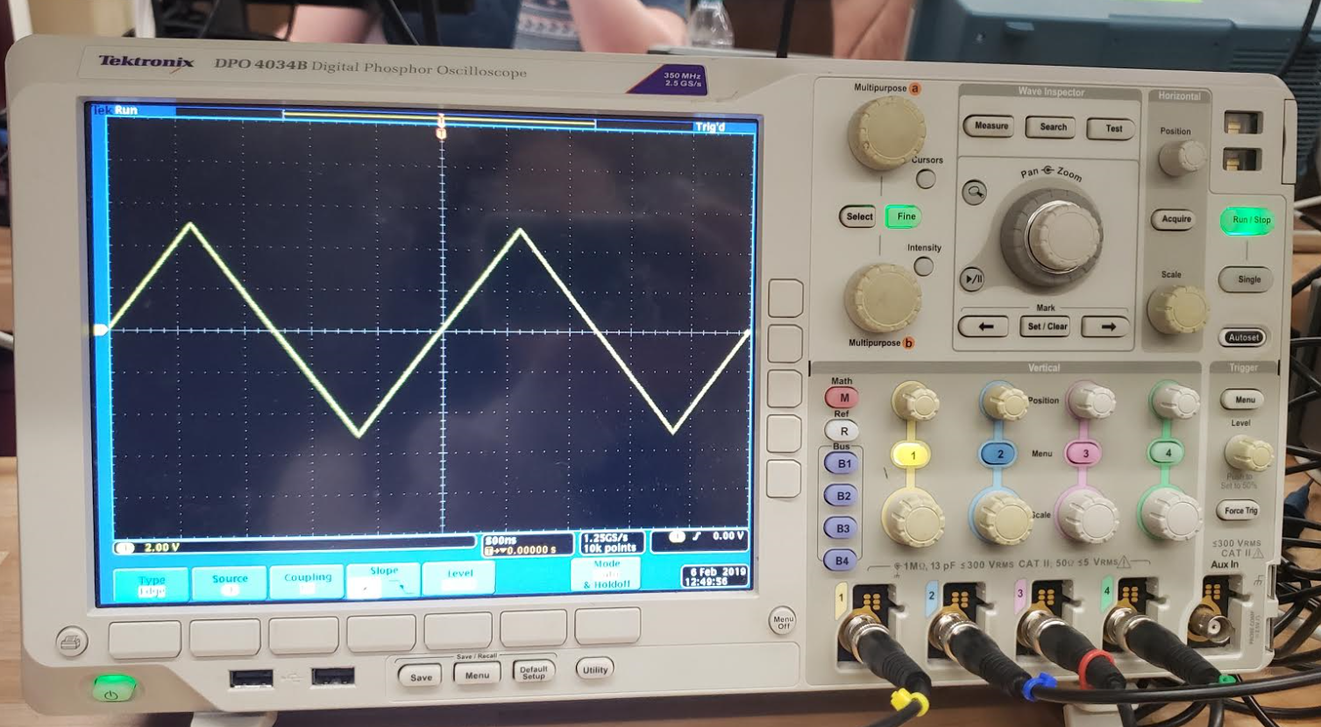

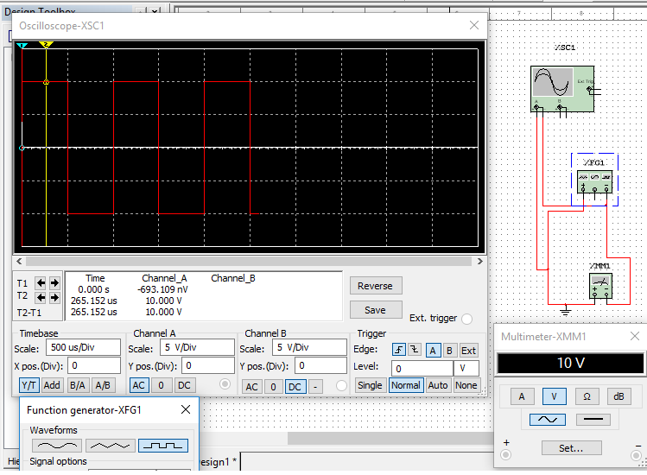

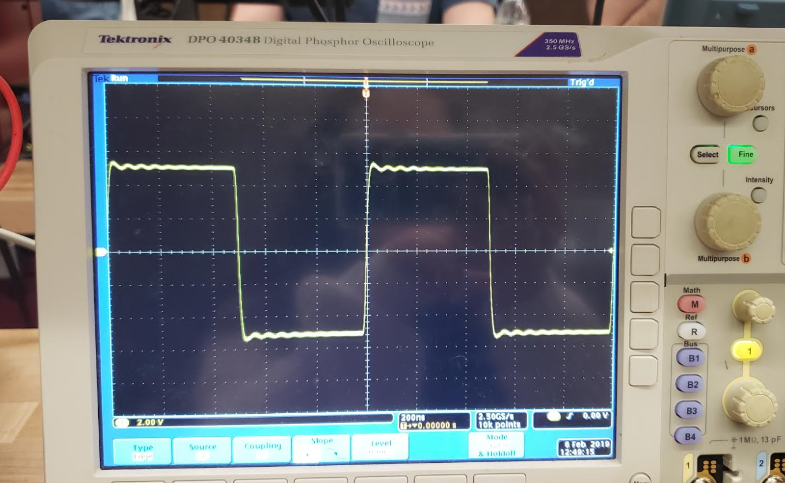

## Experiment

### A. Waveform display and measurement

1. Click the ‘Default Setup’ button located below the LCD screen on the oscilloscope to clear all the settings made by the previous user. For the same purpose, click the ‘Default’ button on the function generator, which is located on the left of the numeric keypad, and then click Enter on the right of the keypad.
2. Set the function generator to run in the ‘Continuous’ mode by clicking the ‘Continuous’ button under ‘Run Mode’. The default mode is the ‘Continuous’ mode.
3. Set the function generator to produce a sine wave by clicking the ‘Sine’ button under ‘Function’.
4. On the function generator, click ‘Output Menu’ located on the right of the LCD screen, select ‘Load Impedance’ then ‘High Z’ option. Click the ‘Top Menu’ button to return to the waveform display screen.
5. Connect Ch.1 of the oscilloscope to the function generator output. Polarities (positive and negative) of both probes must match, i.e. positive to positive, negative to negative. Turn on Channel 1 output by clicking the ‘On’ button of Channel 1 on the function generator. Click the ‘Autoset’ button on the oscilloscope to automatically display the waveform on the LCD screen. How many cycles are displayed?

|  |
| --- |
| 4 cycles. |

1. Click the ‘Square’ button under ‘Function’ on the function generator. What waveform do you observe on the screen of the function generator and oscilloscope?

|  |
| --- |
| A Square waveform is observed. |

1. Click the ‘Ramp’ button under ‘Function’ on the function generator. What waveform do you observe on the screen of the function generator and oscilloscope?

|  |
| --- |
| A Triangle waveform is observed. |

1. Set the waveform back to sinusoidal. Click the ‘Autoset’ button if needed.
2. Click ‘Ch1’ button (yellow) on oscilloscope to bring up the setting options for Ch1. Click it again, what do you see on the screen? Click the button once again, did the waveform show up again? With the options for Channel 1 available on the bottom of the screen, set coupling to DC, and keep the rest at the default setting.

|  |
| --- |
| Screen goes blank (as seen below), the waveform then again shows up with a $V_{pp}$ = 10. |

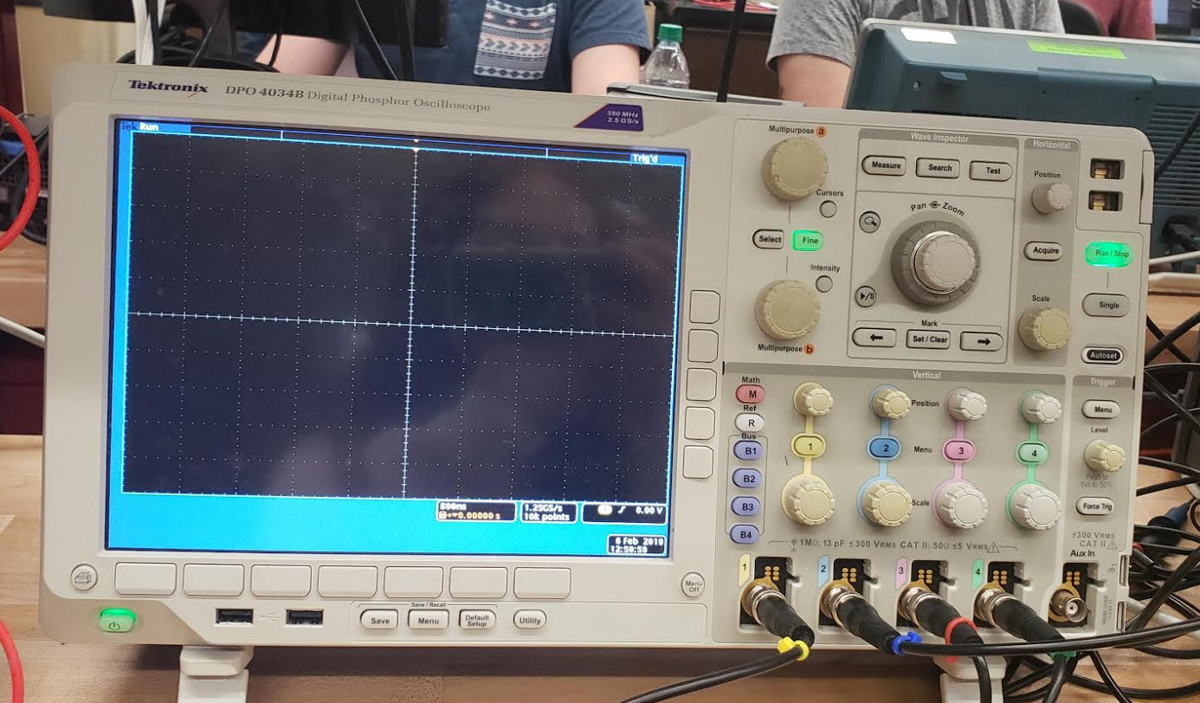

1. Various measurement options for all four channels can be set on the oscilloscope. To do this, click ‘Measure’ button in ‘Wave Inspector’ section and press ‘Add Measurement’ button to bring up the menu. Use the ‘Multipurpose a’ knob to select the source (Ch1, Ch2, Ch3 or Ch4, whichever is available) and ‘Multipurpose b’ knob to select the measurement type. Using the ‘Multipurpose b’ knob highlight the frequency, period, amplitude, mean and RMS, and click on ‘OK Add Measurement’ each time to bring up the readings on the screen. When finished, click on the ‘Menu Off’ button to turn off the menu. (**NOTE:** the amplitude definition might be different from that in your textbook. Make sure to check the definition on the oscilloscope when selecting this measurement.)
2. Vary the frequency and then the amplitude on the function generator. It can be done by clicking on the ‘Frequency/Period’ button or the ‘Amplitude/High’ button, then either type in the number using the numeric keypad or adjust the knob above that. How does the waveform change on the oscilloscope screen? Do the readings on the bottom of the oscilloscope screen change as well? Adjust manually the vertical and/or the horizontal scale if needed. (**NOTE:** the readings on the oscilloscope will not be accurate if the waveform is not properly displayed on the LCD screen, e.g. too few cycles or the waveform exceeds the screen in the vertical direction.)

|  |  |  |
| --- | --- | --- |
|  | Half square | Whole Square |
| F | 5kHz | 5kHz |
| A | 10 $V_{pp}$ | 20 |

|  |
| --- |
| Though for the rest of the lab we will use $V_{pp}$ = 10V and $V_{p}$ = 5V. Values on the bottom of the LCD screen do not vary much. |

1. Vary the channel scale knob in the ‘Vertical’ section and the time scale knob in the ‘Horizontal’ section on the oscilloscope. How does the waveform change on the screen? Do the readings on the bottom of the screen change as well?

|  |
| --- |
| Vertical changes the y-intercept of the waveform and Horizontal moves the cycles horizontal from left to right or right to left. The readings at the bottom of the screen change according to how much the Horizontal and Vertical knobs are moved. |

1. Now, with all the measurement displayed on the screen, set the function generator to output a 1 kHz, 10 $V_{pp}$ sine wave. (Try to keep about 2 – 5 cycles of sine wave displayed on the oscilloscope screen by adjusting both the vertical and horizontal scale knobs in order to obtain an accurate reading.) What do you read for frequency? What do you read for amplitude voltage?

|  |  |
| --- | --- |
| Output of Function generator |  |
| 1kHz | 9.972kHz |
| 10 V | 9.8 V |

1. Click the ‘Menu’ button under ‘Trigger’ on the oscilloscope. Adjust the ‘level’ knob on the oscilloscope. What do you observe when the level line is within the magnitude range of the waveform? How about when it moves outside the magnitude range? Move the level line until it is slightly within the magnitude range and the waveform display is stable.

|  |
| --- |
| Within $→$ sinusoidal stays in place |
| Outside range $→$ moves rapidly and continuously |

1. Keeping the level the same, slowly decrease the amplitude of the input signal on the function generator by adjusting the knob above the numeric keypad when ‘Amplitude’ is highlighted on the screen (if not, click on the ‘Amplitude/High’ button). What do you see on the screen? Describe what you observed in step 14 and 15, and explain why.

|  |
| --- |
| $V_{pp}$ is changing based on the amplitude input $→$ height of the waves are changing |

1. Adjust the level line back to the zero and the signal amplitude back to 10 $V_{pp}$.
2. Adjust the ‘DC offset’ on the function generator by clicking the ‘Offset/Low’ button and set the value to 2 V. What do you observe on the screen of the function generator and oscilloscope?

|  |
| --- |
| The level moved up, zero is not the same spot anymore. |



1. Refer to step 9 and set CH1 coupling to AC. What do you observe on the oscilloscope screen?

|  |
| --- |
| The oscillation does not stop because its AC coupling. |

1. Set CH1 coupling back to DC. What do you observe on the oscilloscope screen?

|  |
| --- |
| Sinusoidal stopped at a random level (depending on when we stop). |

1. Explain the difference between DC and AC coupling.

|  |
| --- |
| AC coupling is useful because the DC component of a signal acts as a voltage offset. DC coupling allows both AC and DC signals to pass through a connection. |

1. Set the ‘DC offset’ on the function generator back to zero.

### Voltage measurements

1. Set the function generator to output a 10 Vpp sine wave.
2. Display the output on Ch.1 of the oscilloscope.
3. With DMM set to measure AC voltage, measure the output of the function generator. Which measurement on the oscilloscope (refer to step 10 of Part A) is this DMM reading equal to, Amplitude or RMS?

|  |
| --- |
| 3.56625V |
| This DMM reading is equal to the RMS voltage of sine wave |

1. Set the function generator to output a 10 Vpp square wave first, followed by a 10 Vpp ramp wave. In each case, what is the reading on the DMM? Are all the measurements consistent with those calculated in PREPARATION?

|  |  |  |
| --- | --- | --- |
|  | Measured | Calculated |
| Square | 4.9978 V | 5V |
| Ramp (Triangle) | 2.889 V | $5/\sqrt{3}$ |

### C. Frequency measurement

1. Set the function generator to output a 1 kHz sine wave. Record the frequency and period readings from the oscilloscope.

|  |  |
| --- | --- |
| Frequency | Period |
| 1.002kHz | 1.00ms |

1. Change the frequency on the function generator to 100 Hz and 100 kHz. What are the frequency and period readings? Adjust manually the horizontal scale if needed. Are all the measurements consistent with those calculated in PREPARATION?

|  |  |
| --- | --- |
| Frequency | Period |
| 100 Hz | 10.03ms |
| 100kHz | 10.01μs |

### D. Test of Knowledge

1. Set the function generator to output a 1 kHz, 4 Vpp sine wave.
2. Display the output on Ch.1 of the oscilloscope by making a direct connection between the oscilloscope and function generator.
3. Verify that the sine wave displayed on the oscilloscope has the same frequency (period) and magnitude as the sine wave displayed on the function generator.
4. Verify that the black post and the 3 red posts on the breadboard are connected to the DC Power Supply.
5. Verify that the DC Power Supply is turned off. **WARNING: Make sure that the DC Power Supply is turned off before proceeding to the next step; otherwise, you may damage the function generator!**
6. Connect the negative terminal (black) of the function generator to the black post on the breadboard.
7. Connect the positive terminal (red) of the function generator to the red post beside the black post on the breadboard.
8. After steps 4 – 7 are completed, use Ch.1 of the oscilloscope to display the output of the function generator. What do you observe on the oscilloscope?
9. Decrease the vertical scale until you see a sine wave on the oscilloscope.
10. Click the ‘Menu’ button under ‘Trigger’ on the oscilloscope. Below the oscilloscope screen, click the button under ‘DC Coupling’ and then select ‘HF Reject’.
11. Observe the sine wave on the oscilloscope. What are the frequency (period) and amplitude of the sine wave?

|  |  |
| --- | --- |
| Frequency | 1kHz |
| Period | 1.0 ms |
| Amplitude | 3.94 V |

1. Does the sine wave displayed on the oscilloscope match the sine wave displayed on the function generator? Why? Provide a detailed reasoning to justify your observations.

|  |
| --- |
| Putting the red cable back in (0-30V controller) positive shorts the circuit and taking at the positive channel opens the circuit. |

1. For good housekeeping habit, remove all connections and put everything back into place after you have completed all the experiments.

### E. Conclusion

In AC circuits, the current and/or voltage sources are time-varying. In this experiment, we focused on sinusoidal, ramp (triangle) and square waveforms. Using the the function generator, we are able to create such wave forms with our desired specifications. In our case, we used peak-to-peak voltage of 10V, and frequency of 1kHZ or about 1 millisecond. We verified that our RMS voltage is $5\sqrt{2}$ V for a sinusoidal waveform with this set $V_{pp}$ and frequency, as well as verification of the square and triangle waveforms. Finally, we showed how the resistance of a function generator can have an effect on the output of our oscilloscope.